Test Case: tc002_SPX_Dev5_Crear_Requisicion_Spot_Tipo_Cobro_Project
Step 1 - Enter username and password and click to button Enter: Credentials Entered
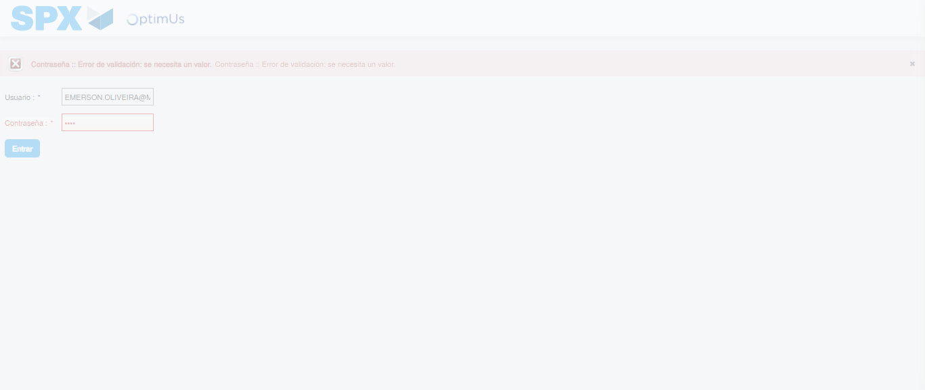Image file-name: QC_Testing-tc002_SPX_Dev5_Crear_Requisicion_Spot_Tipo_Cobro_Project-1784658089746

Step 2 - Select to UEN and Access to Spot Buy Requisitions : UEN Correctly selected and Correct access
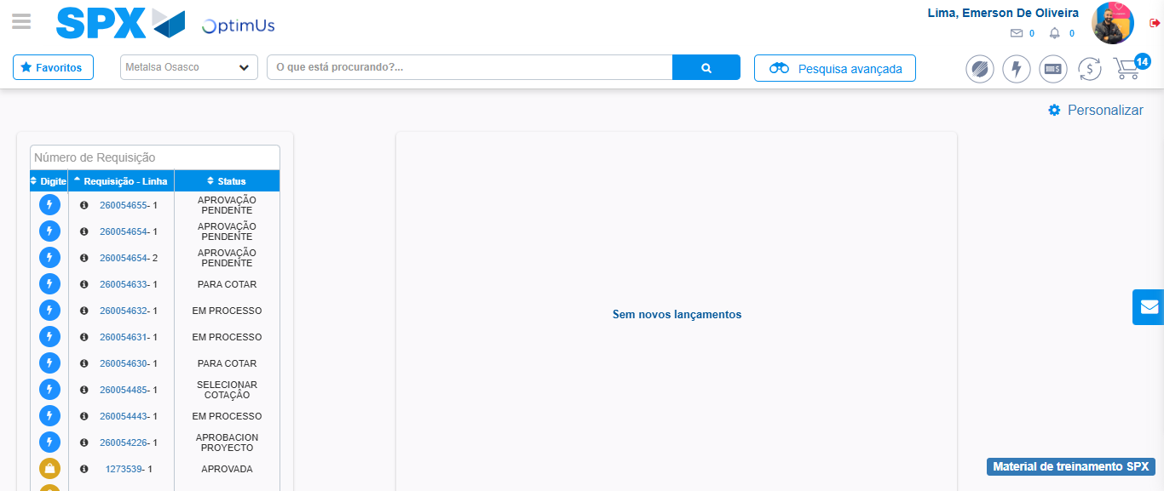Image file-name: QC_Testing-tc002_SPX_Dev5_Crear_Requisicion_Spot_Tipo_Cobro_Project-1784658115762

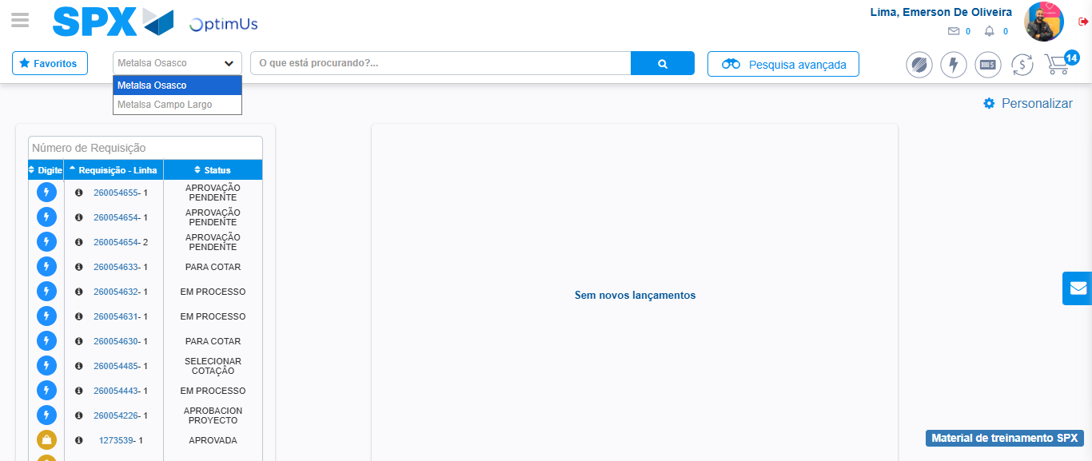Image file-name: QC_Testing-tc002_SPX_Dev5_Crear_Requisicion_Spot_Tipo_Cobro_Project-1784658118243

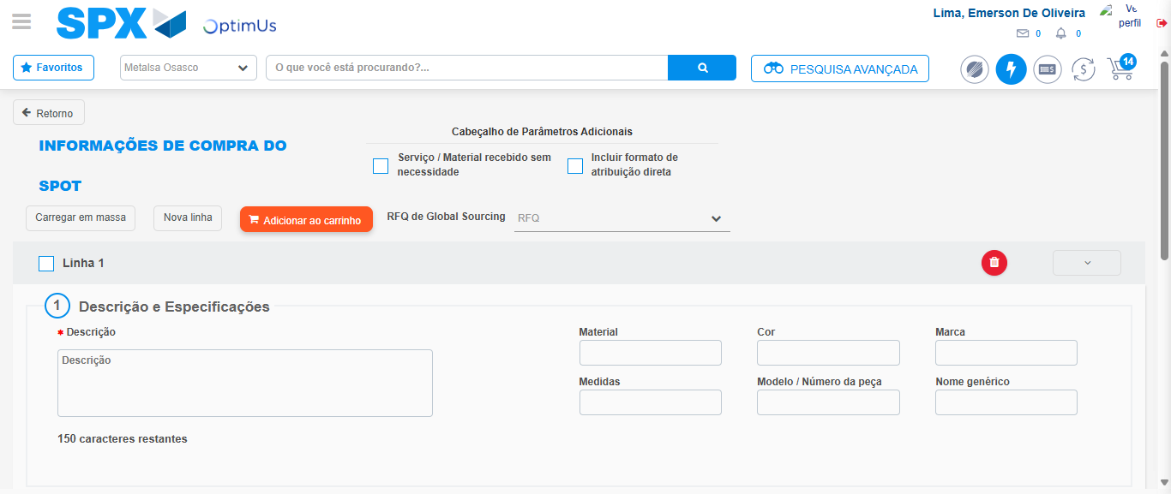Image file-name: QC_Testing-tc002_SPX_Dev5_Crear_Requisicion_Spot_Tipo_Cobro_Project-1784658138035

Step 3 - Data Capture Spot Buy Requisition: Data captured correctly
Image file-name: QC_Testing-tc002_SPX_Dev5_Crear_Requisicion_Spot_Tipo_Cobro_Project-1784658138280

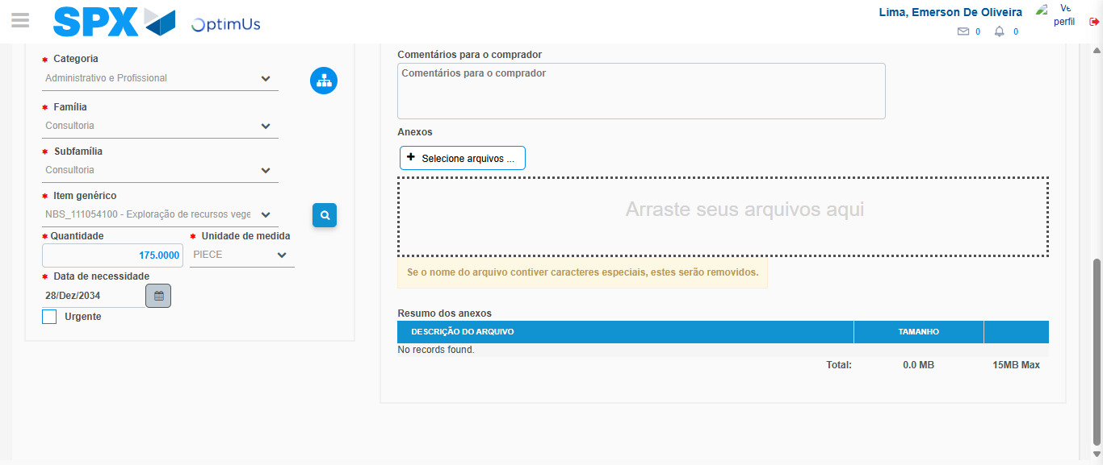Image file-name: QC_Testing-tc002_SPX_Dev5_Crear_Requisicion_Spot_Tipo_Cobro_Project-1784658150295

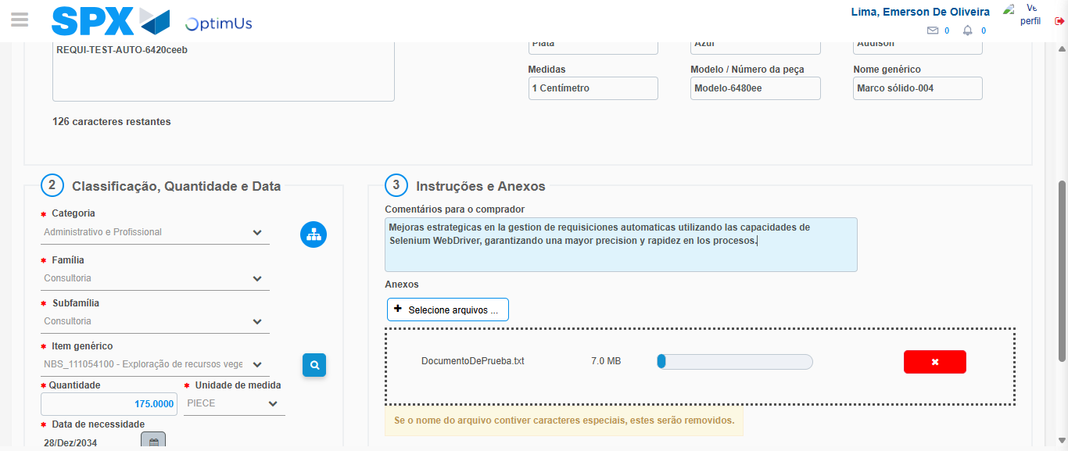Image file-name: QC_Testing-tc002_SPX_Dev5_Crear_Requisicion_Spot_Tipo_Cobro_Project-1784658151159

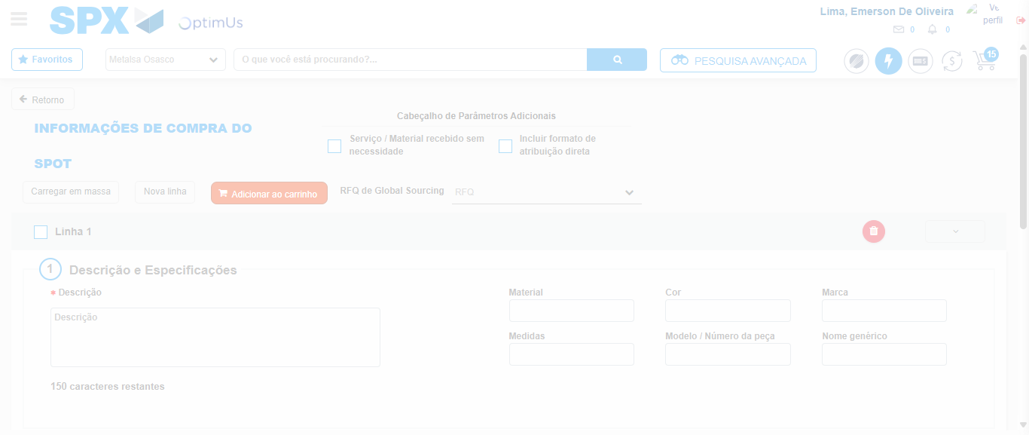Image file-name: QC_Testing-tc002_SPX_Dev5_Crear_Requisicion_Spot_Tipo_Cobro_Project-1784658156537

Step 7 - Return to Main Page SPX : Return to Main Page SPX
Image file-name: QC_Testing-tc002_SPX_Dev5_Crear_Requisicion_Spot_Tipo_Cobro_Project-1784658115762

Image file-name: QC_Testing-tc002_SPX_Dev5_Crear_Requisicion_Spot_Tipo_Cobro_Project-1784658118243

Image file-name: QC_Testing-tc002_SPX_Dev5_Crear_Requisicion_Spot_Tipo_Cobro_Project-1784658138035

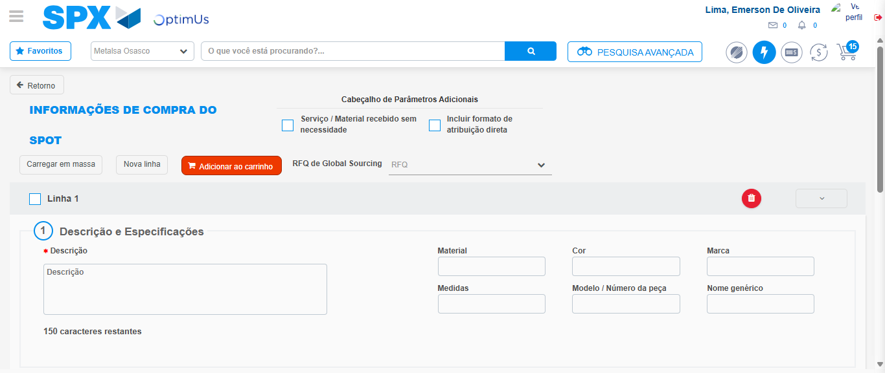Image file-name: QC_Testing-tc002_SPX_Dev5_Crear_Requisicion_Spot_Tipo_Cobro_Project-1784658158751

Image file-name: QC_Testing-tc002_SPX_Dev5_Crear_Requisicion_Spot_Tipo_Cobro_Project-1784658158894

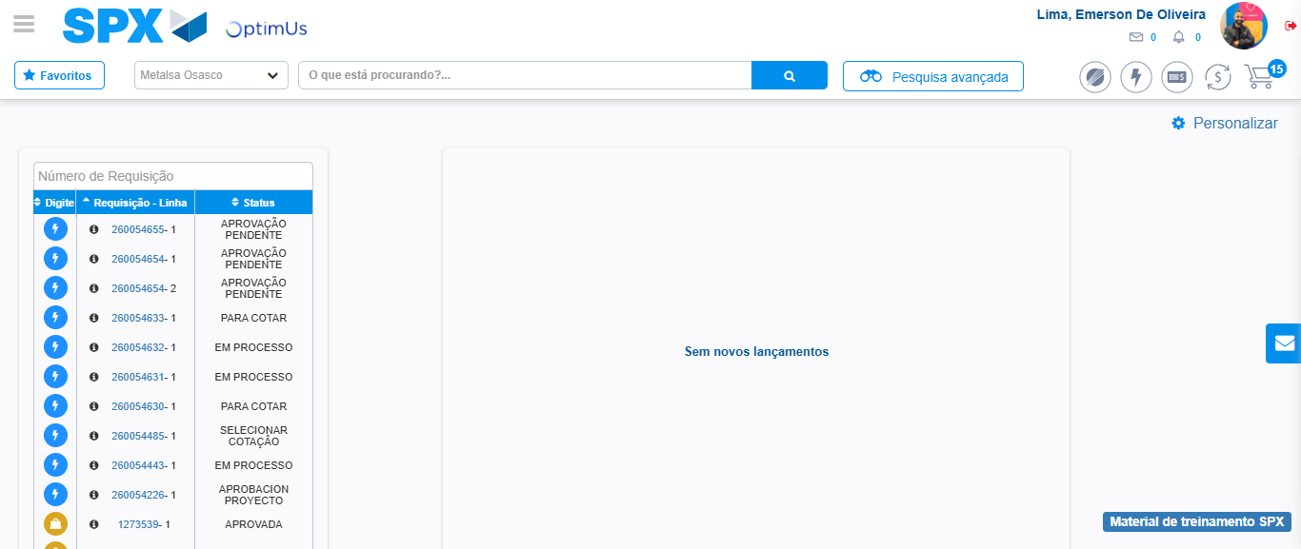Image file-name: QC_Testing-tc002_SPX_Dev5_Crear_Requisicion_Spot_Tipo_Cobro_Project-1784658179977

Step 8 - Log Out : Log Out SPX
Image file-name: QC_Testing-tc002_SPX_Dev5_Crear_Requisicion_Spot_Tipo_Cobro_Project-1784658180171

